## SOFTWARE QUALITY ASSURANCE MANAGEMENT

## NAME:S.Logitha

## REG NO:192121138

**12.USING RAPTOR – COUNT AND PRINT VOWELS IN GIVEN WORD**

**FLOWCHART**

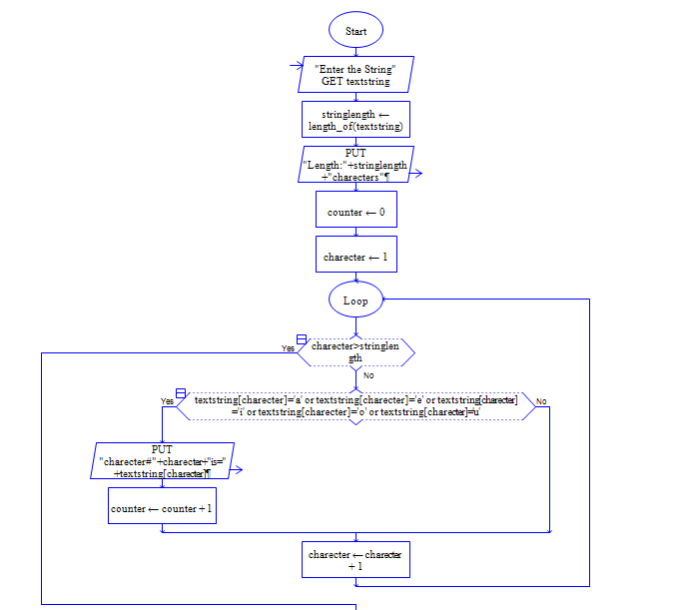



**OUTPUT**

INPUT IS vishnuvardhan

